Computational Neuroscience Homework

HW5: Information theory & Synaptic plasticity

# Exercise 1) Information theory analysis

## A) A model fires at average firing rate r=20Hz. Using Poisson spike generator, generate spike trains for T=1sec, for N=10 repeated trials. Plot the histogram of P(n) for all n’s you observed.

I first generated 10 spike trains, having 1 second as its length, using a Poisson spike generator with 20Hz average firing rate. Below is the raster plot of all 10 trials:

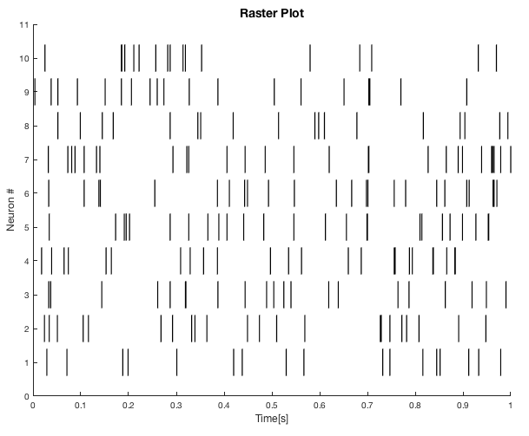

Figure . Raster plot of all 10 spike trains with 20Hz average firing rate, generated by Poisson spike generator.

Then, I counted the number of spikes in each bin, and the bin was defined to have a constant width. (For example, 0s ~ 9s, then 10s~19s, and so on.) I was able to obtain the peri-stimulus time histogram. (PSTH; although here we count the number of spikes, rather than the firing rate) All 10 PSTHs were added up to make an averaged PSTH, shown as below:

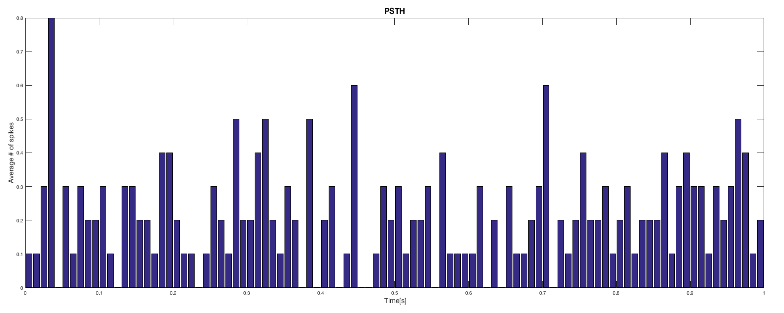

Figure . The average PSTH of all 10 spike trains.

The value of the obtained PSTHs were literally the ‘number of spikes’ observed in time width $Δt$, (10ms in this example) so $P(n)$, which is the probability to observe $n$ spikes in each time width (10ms in this example) was simply obtained by using ‘histogram’ function for the PSTH values:

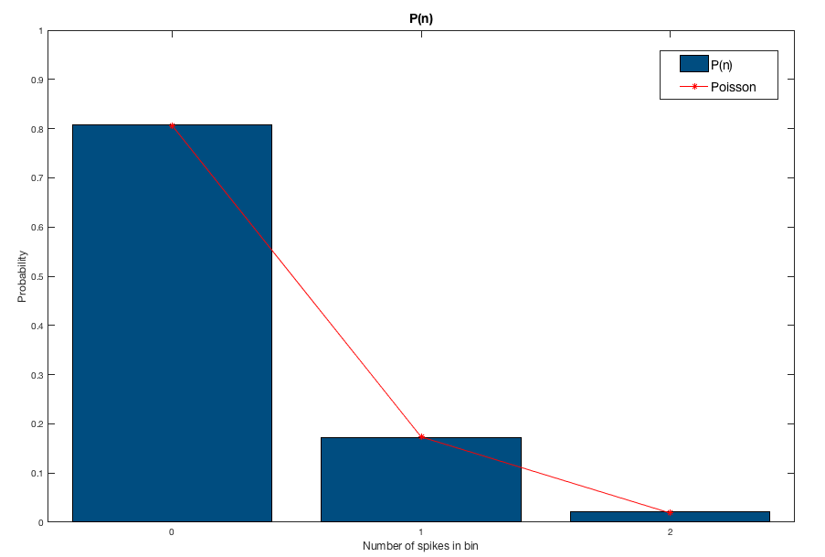

Figure . The probability to observe $n$ spikes in each time width. The red line is the probability value is the Poisson distribution, having the same mean value with the number of spikes observed in 10 spike trains in average. The calculated $P(n)$ is very similar to the Poisson distribution, thus we were able to confirm the fact that the spike train is generated with a Poisson process.

As shown in Figure 3, the theoretical Poisson distribution matched very well with the calculated $P\left(n\right)$.

## B) Using above result, calculate the entropy S, and the entropy per spike, S/<n>.

Using the fact that entropy S is

$$S=-\sum_{n}{P\left(n\right)}\log_{2}{P\left(n\right)}$$

we can obtain the entropy of spike trains. Then, simply dividing it with the average number of spikes observed in the 10 spike trains, entropy per spike can also be obtained. In ‘Prob1b.m’, the bin width was 100ms to calculate $P(n)$, and the result was obtained as below:

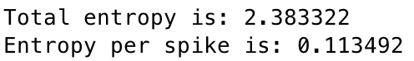

Also, to confirm whether the $P(n)$ is well obtained as expected, (whether it follows a Poisson distribution) the obtained $P(n)$ was compared with the theoretical $P(n)$ as below:

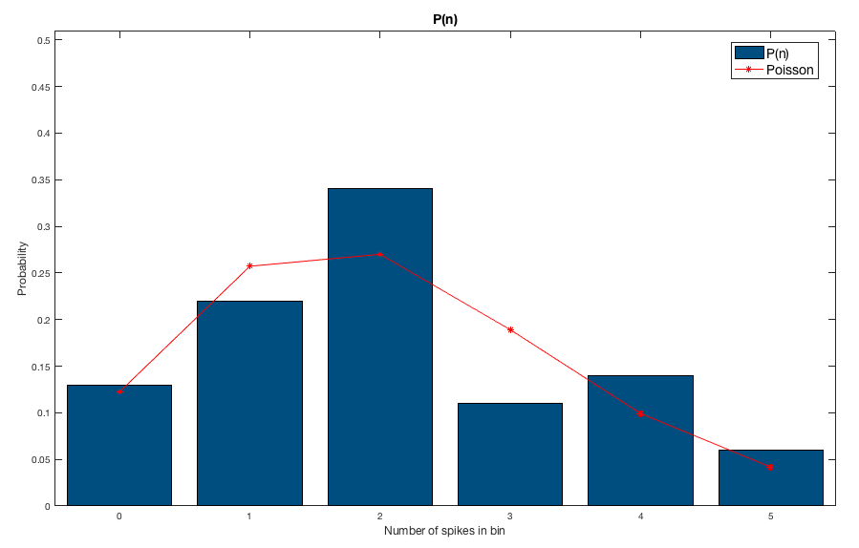

Figure . Comparison between experimentally obtained $P\left(n\right)$ and theoretical probability of a Poisson distribution.

Although the shape was quite similar with the theoretical Poisson distribution, the observed value was slightly different compared to the theoretical value. This is due lack of obtaining sufficient number of spike trains, and the details will be discussed in D).

## C) Compare above result with analytically calculate result, assuming P(n) is a Poisson distribution. Discuss possible reasons of differences between two cases.

If the $P\left(n\right)$ follows a Poisson distribution, since

$$S=-\sum_{n}{P\left(n\right)}\log_{2}{P\left(n\right)}=-\frac{1}{\ln{2}}\sum_{n}{P\left(n\right)}\ln{P\left(n\right)}$$

and

$$P\left(n\right)=\frac{N^{n}e^{-N}}{n!}$$

$$S=-\frac{1}{\ln{2}}\sum_{n}{P\left(n\right)\left(n\ln{N}-N-\ln{n!}\right)}$$

Then, using the fact that

$$\sum_{n}{nP(n)}=N=N\sum_{n}{P(n)}=\sum_{n}{NP(n)}$$

$$\sum_{n}{f(n)P(n)}≈f\left(N\right)$$

we can approximate the entropy as

$$S=-\frac{1}{\ln{2}}\sum_{n}{P\left(n\right)\left(n\ln{N}-N-\ln{n!}\right)}=-\frac{1}{\ln{2}}\left(N\ln{N}-N-\left(N+\frac{1}{2}\right)\ln{N}+N-\frac{1}{2}\ln{2π}\right)$$

$$=-\frac{1}{\ln{2}}\left(-\frac{1}{2}\ln{N}-\frac{1}{2}\ln{2π}\right)=\frac{1}{2}\log_{2}{N}+\frac{1}{2}\log_{2}{2π}$$

Now, I compared the ‘analytically calculated result’ with the experimentally observed entropy of the spike train. Here, I set the bin width to be 100ms, and the result was as below:

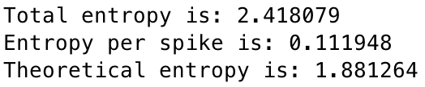

The experimentally observed entropy (total entropy) was approximately 2.42, whereas the analytically calculated entropy (theoretical entropy) was approximately 1.88.

However, all 10 spike trains were generated using Poisson spike generator, thus theoretically, the experimentally attained entropy should be similar to the analytically calculated entropy. Then, what made the difference between these two quantities? Let’s first compare the $P\left(n\right)$ attained in the observation with the theoretical Poisson distribution:

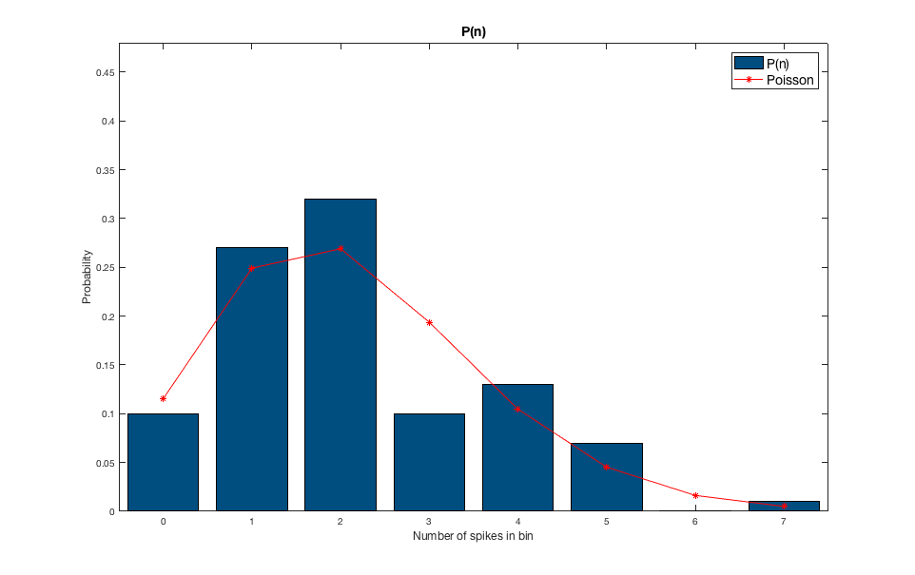

Figure . Comparison between the $P\left(n\right)$ attained based on the 10 spike trains (blue bar), and the Poisson distribution. (red line)

As shown in Figure 5, although $P\left(n\right)$ shown a similar shape with the Poisson distribution, the exact value was different compared to the theoretical probability. Since the entropy attained based on the observation of 10 spikes are calculated using $P\left(n\right)$, error in $P\left(n\right)$ might have caused the difference between the observed entropy and theoretical entropy.

Also, the theoretical entropy equation was derived using Sterling’s approximation ($\ln{N!}≈N\ln{N}-N+\frac{1}{2}\ln{2π}$) and this approximation holds when $N≫1$.

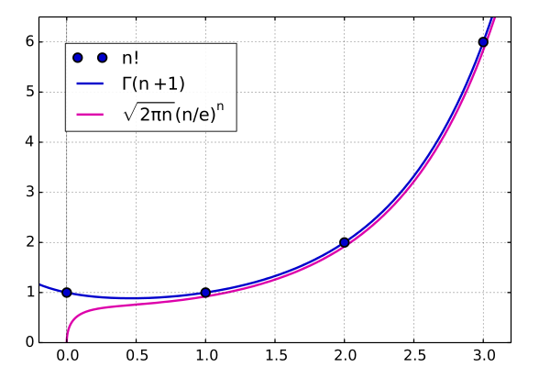

Figure . The comparison between $\ln{N!}$ (blue line) and $N\ln{N}-N+{\ln{2π}}/2$ (pink line). The Sterling’s approximation holds well when $N$ is large enough.

$N$ is the average number of spikes observed in the bin, and thus for the theoretical entropy to be same with the observed entropy, $N$ should be large enough. To confirm whether this is true, I changed the mean firing rate of the Poisson spike generator from 0 to 350Hz. Then, $N$ and the observed entropy, theoretical entropy were calculated, and the result was as below[1]:

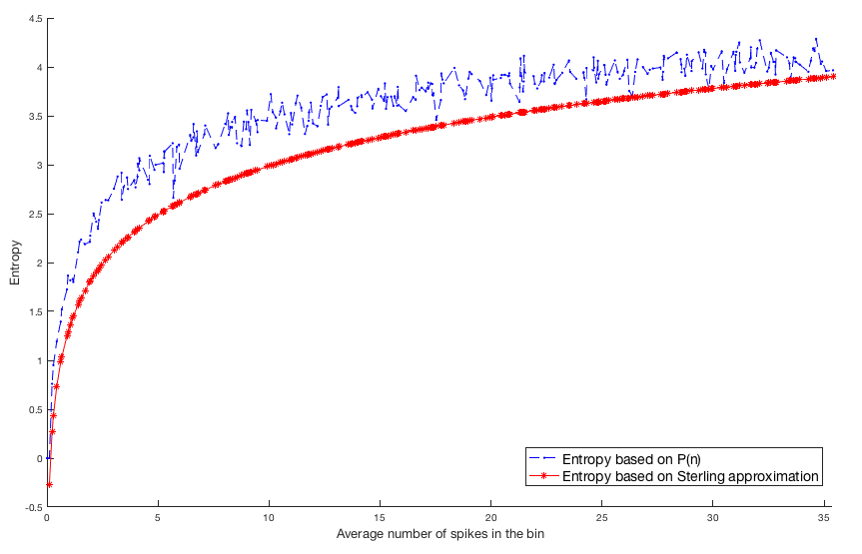

Figure . The comparison between entropy calculated based on $P\left(n\right)$ (observed entropy) and the entropy calculated based on Sterling’s approximation (theoretical entropy). The difference between two curves tend to converge to zero as the average number of spikes in the bin increases.

As I predicted, the difference between the observed entropy and the theoretical entropy decreased as the average number of spikes in the bin increased.

## D) Repeat a) and b) for N=1000 repeated trials and compare with c). Discuss possible problems of estimating entropy in animal experiments.

Using the same code, but different number of trials (the number of trials changed from 10 to 1000), we obtained $P\left(n\right)$, observed entropy, entropy per spike, and theoretical entropy:

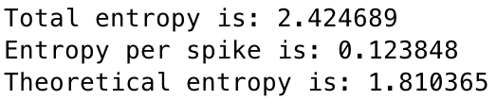

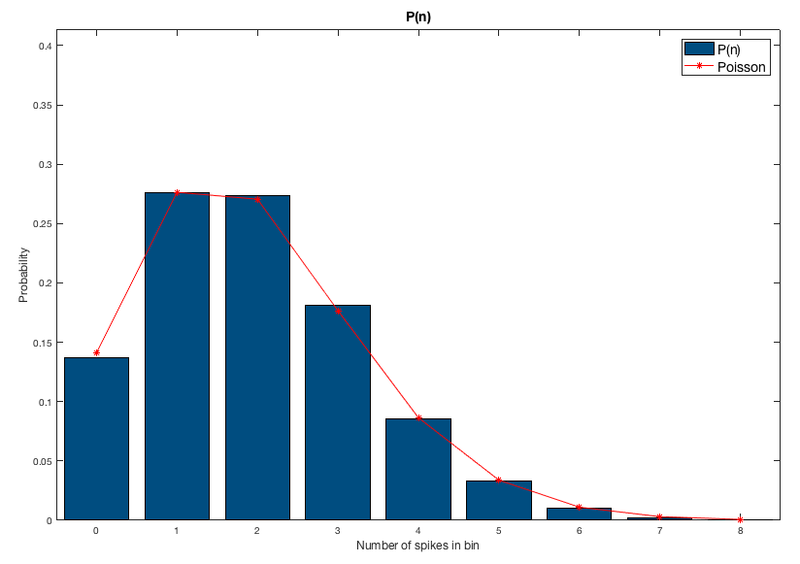

Figure . Comparison between the $P\left(n\right)$ attained based on the 1000 spike trains (blue bar), and the Poisson distribution. (red line)

As shown in Figure 8, the obtained $P\left(n\right)$ is very similar to the theoretical Poisson distribution. However, the observed entropy, entropy per spike, and the theoretical entropy didn’t change significantly compared to the case where only 10 spike trains were obtained. To obtain a clearer insight, I again attained the $N$ vs. entropy curve for both observed and theoretical case[2]:

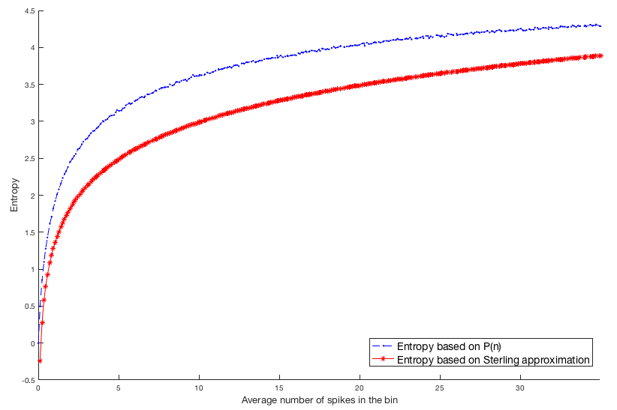

Figure . The comparison between entropy calculated based on $P\left(n\right)$ (observed entropy) and the entropy calculated based on Sterling’s approximation (theoretical entropy).

The theoretical entropy curve is same as in the 10 spike train case, and the main difference is that the observed entropy curve seems more ‘stabilized’. This is due to a well approximation of $P\left(n\right)$, since 1000 spike trials have much more samples to estimate the distribution. Thus, to sum up, increasing the number of spike trains allows a better approximation of $P\left(n\right)$, and thus the entropy is much more ‘well estimated’. Also, to use the Sterling’s approximation form of Poisson spike train entropy equation, we should check whether the average number of spikes in the bin, $N$, is large enough.

Since the average number of spikes in the bin can be controlled by setting the bin width as an appropriate value, what we must more concern here is ‘the sufficient number of spikes needed for estimating $P\left(n\right)$ appropriately’. As we get many spike trains as possible, the accuracy would increase, but obtaining too many spike train data in the experiment would be a waste of time. To solve this dilemma, I suggest finding the number of spikes needed, based on calculating the root mean square error between the distribution based on observation, and the theoretical distribution: assume that we collected $i$ spike trains, and the average number of spikes in the bin is $N_{i}$. If we say $P(n_{i}$) to be the observed distribution and $Poi\left(n_{i}, N_{i}\right)$ to be the theoretical Poisson distribution, we stop to collect spike trains when

$$\sqrt{\frac{\sum_{n_{i}}{{\left[P\left(n_{i}\right)-Poi\left(n_{i},N_{i}\right)\right]}^{2}}}{\sum_{n_{i}}{1}}}<threshold$$

is satisfied.

# Exercise 2) Spike Timing Dependent Plasticity

## A) Using proper equation and parameters, implement this STDP and plot the $Δ$ EPSC(%) as a function of $Δ$ t=[-100, 100]ms.

For $ΔEPSC\left(10\right)=ΔEPSC\left(0\right)/e$, when we assume that the $ΔEPSC$ equation is set as

$$ΔEPSC\left(t^{post}-t^{pre}\right)=e^{∓{\left(t^{post}-t^{pre}\right)}/{τ^{±}}}Θ\left(±\left[t^{post}-t^{pre}\right]\right)$$

, we $τ^{+}$ is 10. To make the problem simple, I assume that the STDP curve of $Δ$ EPSC is asymmetric, thus $τ^{-}$ would be 10 too.

Based on this logic, I constructed the $Δ$ EPSC in the range of $Δt= [-100, 100]$ ms:

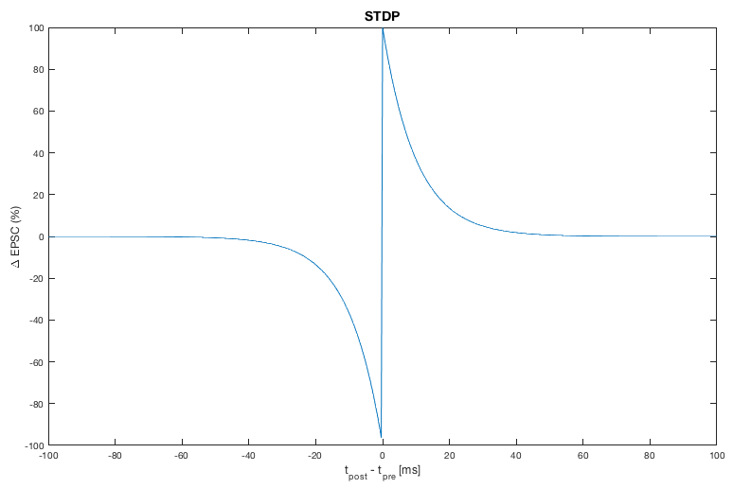

Figure . The vs. EPSC(%) graph.

## B) Suppose both pre- and post-synaptic spike is random Poisson spike trains of firing rate 20Hz, independent to each other. Generate these spike trains and plot the pre- and post-spike trains with the instantaneous change ratio of EPSC (initially 1) together, for T=10sec.

Two spike trains were generated using Poisson spike generator, and the moment where the EPSC changes were needed to be investigated. The first hurdle is that the ‘updating moment’ can be either the time where post-synaptic spike or the pre-synaptic spike is generated:

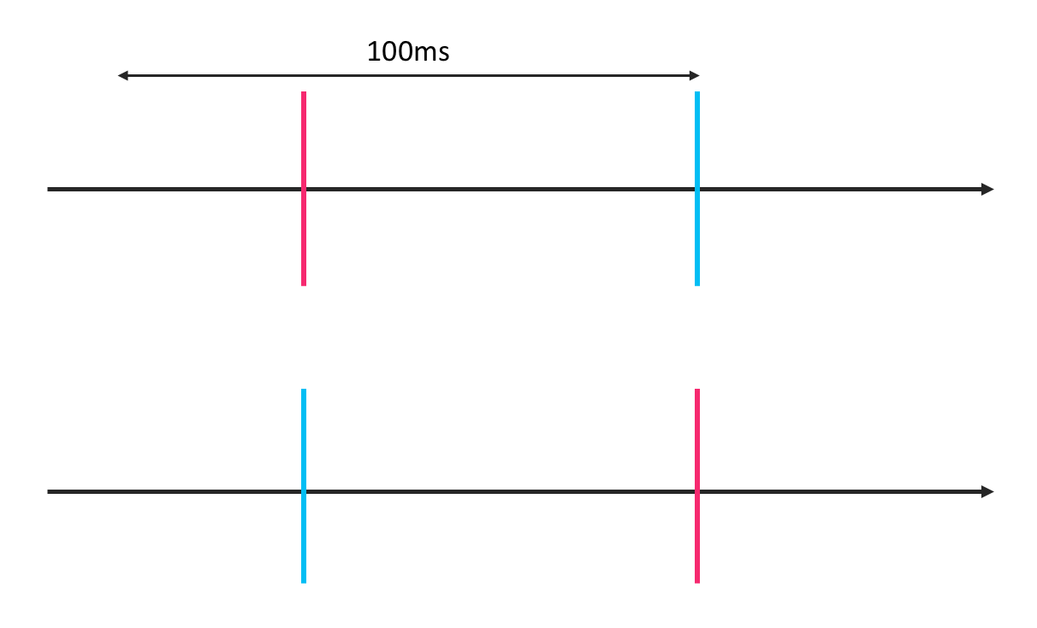

Figure . Two cases are possible: the pre-synaptic spike (red) can be observed ‘before’ the post-synaptic spike (blue), as in the top case, or ‘after’ as in the bottom case.

In both case, the updating moment should be the moment when the latter spike is generated.

Now, there is another problem. What if there are more than one pre-synaptic spikes in range of [-100ms, 0ms] relative to the post-synaptic spike? (or, *vice versa*?)

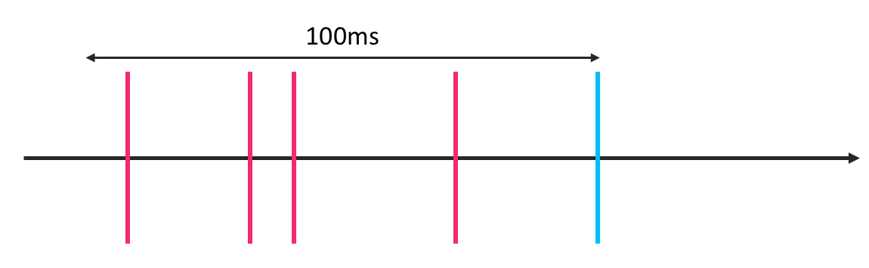

Figure . The case where there is more than one pre-synaptic spikes in range of [-100ms, 0ms] relative to the post-synaptic spike.

How should we decide $Δt$ value that is used to obtain $Δ$ EPSC? Here, I decided that the ‘closest’ pre-synaptic spike to the post-synaptic spike – pre-synaptic spike with the smallest $\left|Δt\right|$ value – should be used to calculate $Δ$ EPSC.

These rules were implemented in the code, and below is the result:

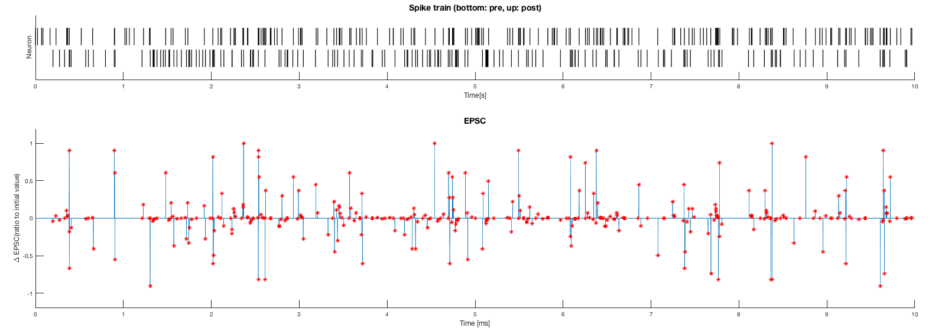

Figure . Spike train of pre-synaptic spike (bottom) and post-synaptic spike, when the spike trains are independent from each other (top). (Top Figure) The $Δ$ EPSC plotted with the time axis. Red dots are the moment where the EPSC changes (in other words, the moment when $Δ$ EPSC is not 0). (Bottom Figure)

The ratio of the $Δ$ EPSC is defined as below:

$$ΔEPSC=\frac{EPSC_{current}-EPSC_{previous}}{EPSC_{inital}}$$

Also, I calculated the change ratio of EPSC as

$$ΔEPSC_{ratio}=\frac{EPSC_{current}}{EPSC_{previous}}$$

and obtained the quantity as below:

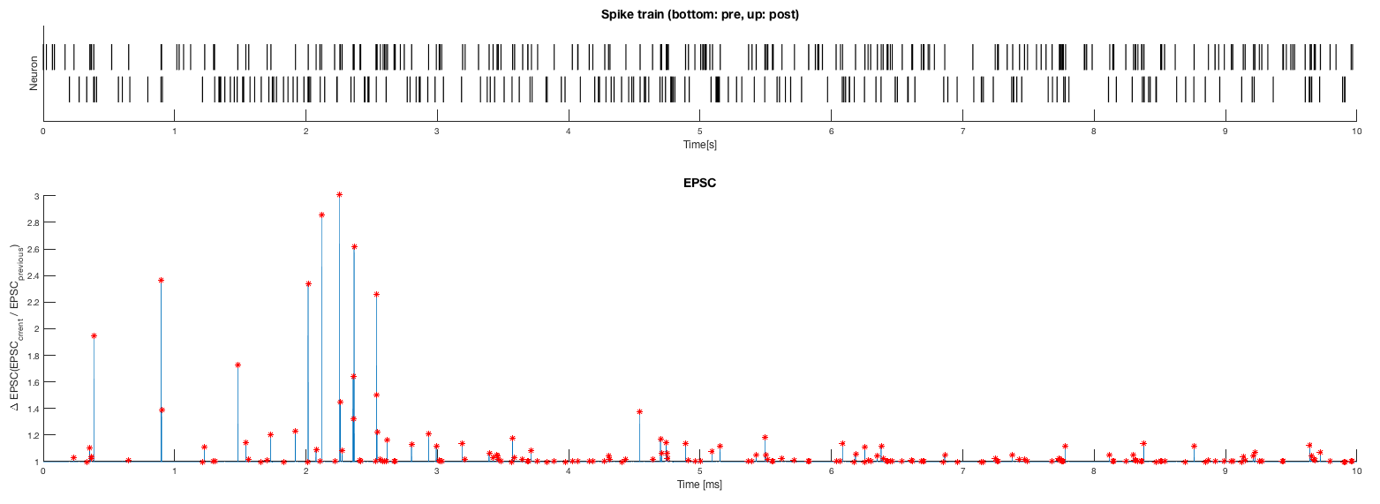

Figure . Spike train of pre-synaptic spike (bottom) and post-synaptic spike, when the spike trains are independent from each other (top). (Top Figure) The $ΔEPSC_{ratio}$ plotted with the time axis. Red dots are the moment where the EPSC changes (in other words, the moment when $ΔEPSC_{ratio}$ is not 1). (Bottom Figure)

## C) Now suppose that mean post-synaptic rate is 20Hz within 20ms after a pre-synaptic spikes, and 5Hz otherwise. Plot the pre- and post-synaptic spike trains and the change ratio of EPSC again, for T=10sec.

Using the same idea as in Prob2b, the result was obtained as below:

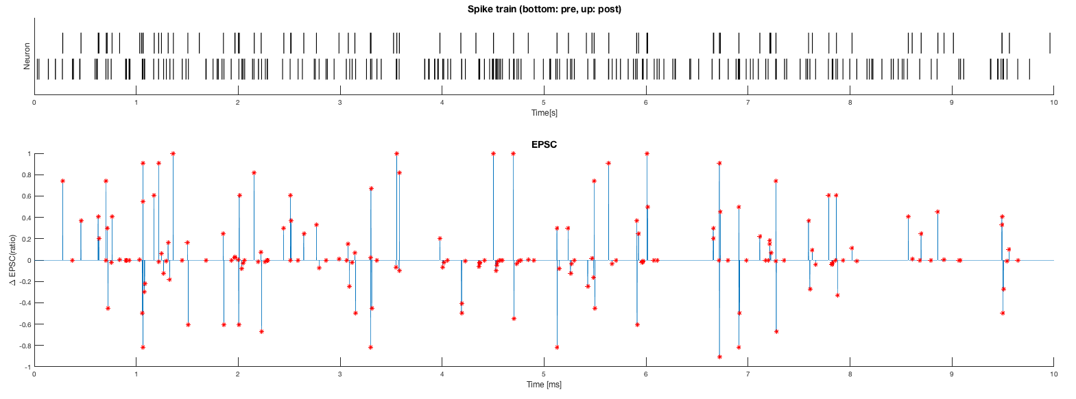

Figure . Spike train of pre-synaptic spike (bottom) and post-synaptic spike, when the post-synaptic spikes are dependent to the spike timings of the pre-synaptic spikes (top). (Top Figure) The $Δ$ EPSC plotted with the time axis. Red dots are the moment where the EPSC changes (in other words, the moment when $Δ$ EPSC is not 0). (Bottom Figure)

The main difference between problem 2b and 2c is that the post-synaptic spikes are dependent to the spike timings of the pre-synaptic spikes in problem 2c, whereas it is independent in problem 2b. In problem 2c, the firing rate is normally 5Hz, and it only changes to 20Hz after a pre-synaptic spike is generated, for 20ms. As we can confirm by comparing Figure 14 and 15, the $Δ$ EPSC larger than 0 is more observed in problem 2c. This is obvious since it is more likely to observe a post-synaptic spike ‘after’ a pre-synaptic spike in problem 2c, whereas we have similar chance to observe a post-synaptic spike ‘before’ or ‘after’ a pre-synaptic spike in problem 2b.

Also, the number of ‘updating moments’ decreased in problem 2b, since the post-synaptic spike train’s mean firing rate is 5Hz in default, and only changes to 20Hz when a pre-synaptic spike is generated. Also, I obtained the $ΔEPSC_{ratio}$ as in Prob2b:

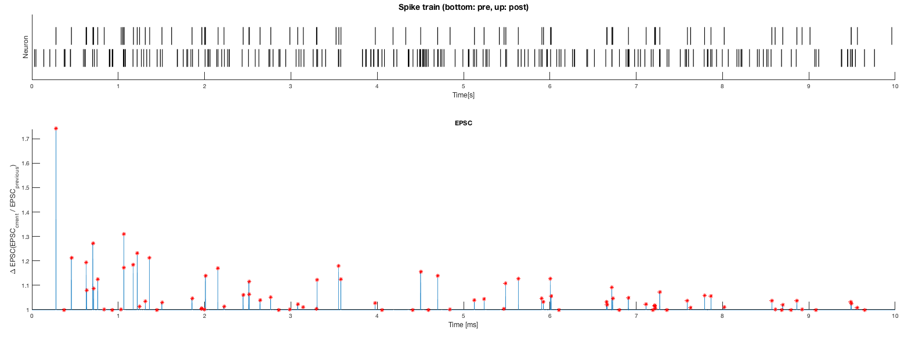

Figure . Spike train of pre-synaptic spike (bottom) and post-synaptic spike, when the post-synaptic spikes are dependent to the spike timings of the pre-synaptic spikes (top). (Top Figure) The $ΔEPSC_{ratio}$ plotted with the time axis. Red dots are the moment where the EPSC changes (in other words, the moment when $ΔEPSC_{ratio}$ is not 1). (Bottom Figure)

Here, the result was also similar to Figure 14.

## D) Now implement a restraint in the model in c) so that the EPSC cannot exceed 3 times of initial value. Again plot spike trains and EPSC change in c).

In reality, EPSC cannot be lower than 0, and neither can exceed some certain value. Here, the maximum value is set to be 3 times of the initial value. Since we set the initial EPSC value as 1, we will use some constraints. First, I will use the additive rule. Additive rule is as below:

$$ΔEPSC^{±}=\left\{\begin{aligned}a^{±} k\left(Δt\right) \left(EPSC_{min}<EPSC<EPSC_{max}\right) \\ 0 otherwise \end{aligned}\right.$$

Based on this rule, I obtained the result as below:

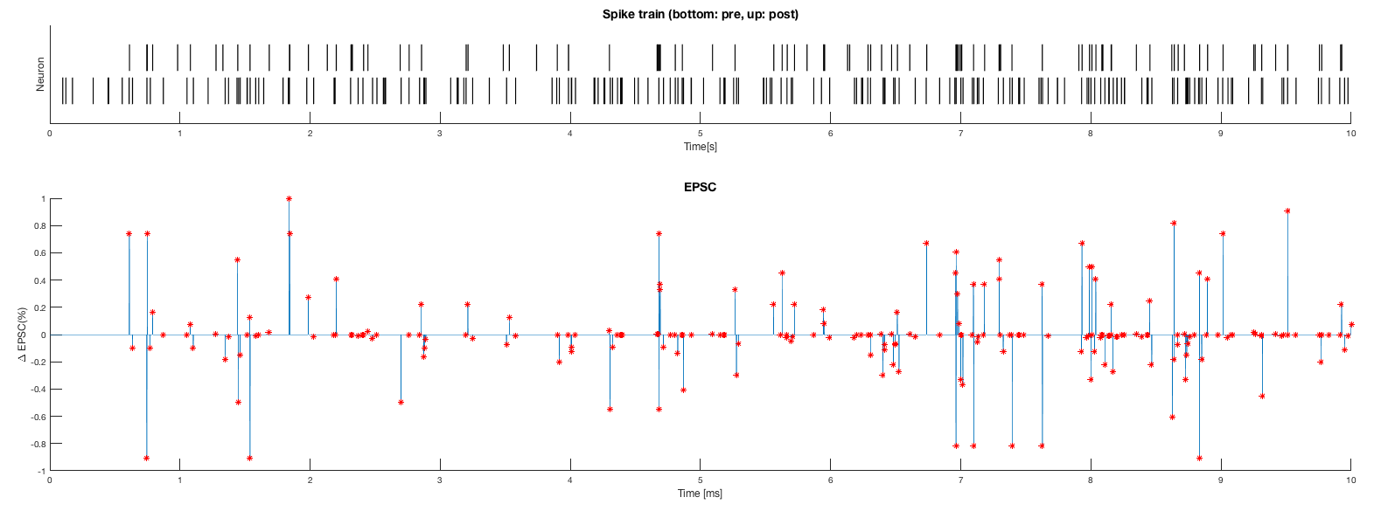

Figure . Spike train of pre-synaptic spike (bottom) and post-synaptic spike, when the post-synaptic spikes are dependent to the spike timings of the pre-synaptic spikes (top). (Top Figure) The $Δ$ EPSC plotted with the time axis when the EPSC value is constraint in certain range (additive). Red dots are the moment where the EPSC changes (in other words, the moment when $Δ$ EPSC is not 0). (Bottom Figure)

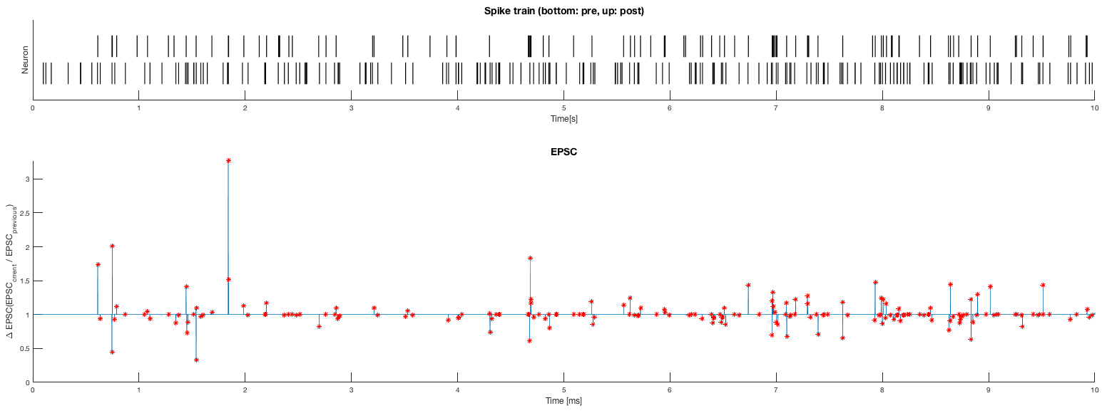

Figure . Spike train of pre-synaptic spike (bottom) and post-synaptic spike, when the post-synaptic spikes are dependent to the spike timings of the pre-synaptic spikes (top). (Top Figure) The $ΔEPSC_{ratio}$ plotted with the time axis when the EPSC value is constraint in certain range (additive). Red dots are the moment where the EPSC changes (in other words, the moment when $ΔEPSC_{ratio}$ is not 1). (Bottom Figure)

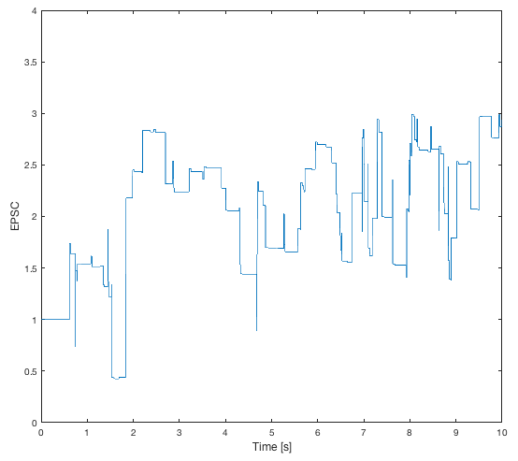

Figure . EPSC value changing as time passes when the pre- and post-synaptic neuron are correlated. (Additive model) The EPSC value became relatively high (near 3) after 10s of spike stimulus.

As shown in Figure 19, the EPSC value increased near to 3 after 10s of learning: Post-synaptic neuron fired when the pre-synaptic neuron fired, inducing the increase of EPSC.

I also tried the case where EPSC ‘saturates’ when it meets its optimum range, following the rule below:

$$ΔEPSC^{±}=\left\{\begin{aligned}a^{±} k\left(Δt\right) \left(EPSC_{min}<EPSC+ΔEPSC^{±}<EPSC_{max}\right) \\ S otherwise \end{aligned}\right.$$

where S is the value that makes the EPSC to reach the optimum. (maximum if $ΔEPSC^{+}$, minimum if $ΔEPSC^{-}$) The EPSC was as below:

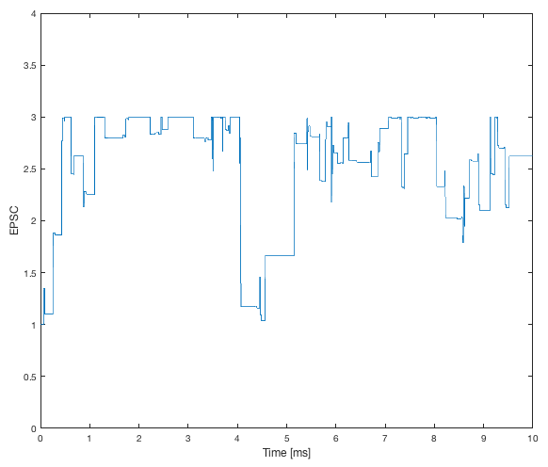

Figure . EPSC value changing as time passes when the pre- and post-synaptic neuron are correlated. (Saturation model) The EPSC value became relatively high (near 3) after 10s of spike stimulus.

This model seemed to reach the maximum EPSC more quickly, and tended to have a more stabilized EPSC value.

Then what about the case where pre-synaptic neuron and the post-synaptic neuron are independent from each other? I made additional code, ‘Prob2d_Indep.m’ to confirm how EPSC changes when pre-, post-synaptic neuron are independent from each other:

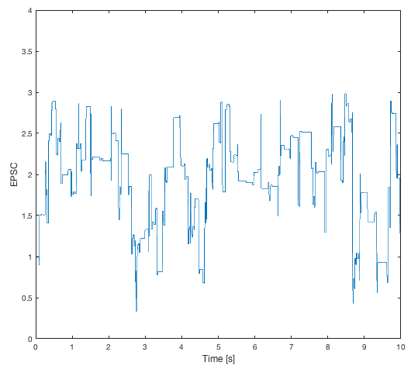

Figure . EPSC value changing as time passes when the pre- and post-synaptic neuron are independent. The EPSC value oscillates, thus the EPSC value tend not to converge to some certain value.

In this case, the EPSC oscillated continuously. Although more quantitative analysis are required for further discussion, I briefly confirmed that EPSC only increases constantly when pre-synaptic and post-synaptic neurons are correlated to each other.

I also made a model using the multiplicative rule, as below:

$$ΔEPSC^{±}=\left\{\begin{aligned}a^{+} k\left(Δt\right)\left(EPSC_{max}-EPSC\right) \\ a^{-} k\left(Δt\right)\left(EPSC-EPSC_{min}\right) \end{aligned}\right.$$

Now, the question is ‘how to select proper range of $a^{±}$ to prevent EPSC to be in the range of $(EPSC_{min}$, $EPSC_{max}$). We can say that

$$ΔEPSC=\frac{EPSC_{new}-EPSC_{old}}{EPSC_{old}}×100$$

Let’s say that the EPSC follows the rule as below:

$$EPSC_{i+1}=EPSC_{i}+ΔEPSC=EPSC_{i}+a^{±}k\left(Δt\right)\left(EPSC_{max}-EPSC_{i}\right)$$

Let’s say that $EPSC_{i}=EPSC_{max}-δ$ so that

$$EPSC_{i+1}=EPSC_{i}+ΔEPSC=EPSC_{max}-δ+a^{±}δk\left(Δt\right)$$

Thus,

$$a^{±}k\left(Δt\right)-1<0$$

for all $Δt$, and the maximum $k\left(Δt\right)$ value would be 1. Thus, at least if $0<a^{±}<1$, EPSC would not exceed its maximum value.

Based on this rule, I generated the EPSC model with multiplicative rule in ‘Prob2d_Multiplicative.m’ code, and obtained the result as below:

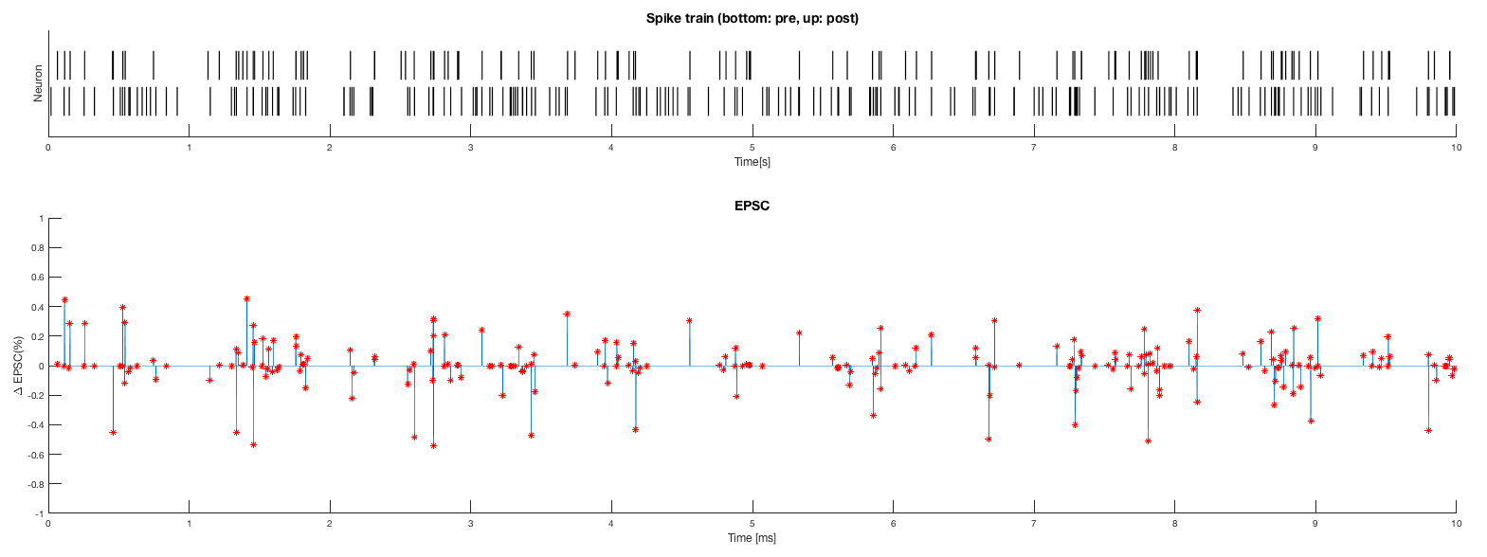

Figure . Spike train of pre-synaptic spike (bottom) and post-synaptic spike, when the post-synaptic spikes are dependent to the spike timings of the pre-synaptic spikes (top). (Top Figure) The $Δ$ EPSC plotted with the time axis when the EPSC value is constraint in certain range (multiplicative). Red dots are the moment where the EPSC changes (in other words, the moment when $Δ$ EPSC is not 0). (Bottom Figure)

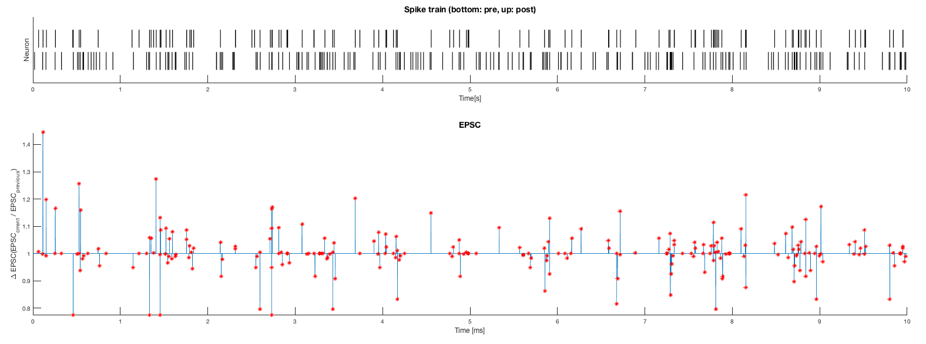

Figure . Spike train of pre-synaptic spike (bottom) and post-synaptic spike, when the post-synaptic spikes are dependent to the spike timings of the pre-synaptic spikes (top). (Top Figure) The $ΔEPSC_{ratio}$ plotted with the time axis when the EPSC value is constraint in certain range (multiplicative). Red dots are the moment where the EPSC changes (in other words, the moment when $ΔEPSC_{ratio}$ is not 1). (Bottom Figure)

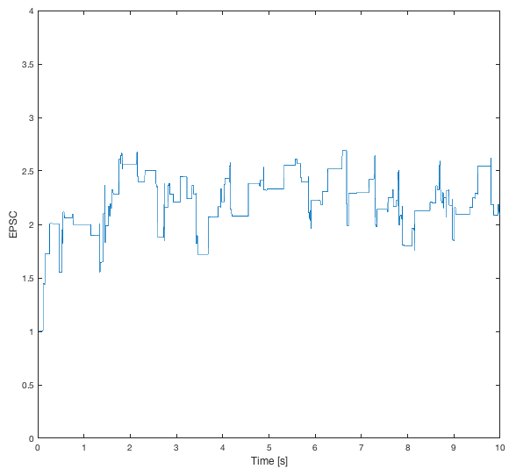

Figure . EPSC value changing as time passes when the pre- and post-synaptic neuron are correlated. (Multiplicative model) The EPSC value became relatively high (near 3) after 10s of spike stimulus.

As same as for the case of the additive rule model, the EPSC tended to increase.

As a conclusion, for positively correlated pre-synaptic and post-synaptic spike trains, the EPSC increased. In contrast, independent pre- and post-synaptic spike trains did not increase or decrease EPSC significantly. However, more quantitative analysis are required for detail comparison to investigate the relation between EPSC value and spike trains.

1. The code for this is ‘Prob1c_Discussion.m’.
2. The code used for this task is ‘Prob2d_Discussion.m’.